Exercise 13

- Which command displays the MYSQL version?
SELECT VERSION();
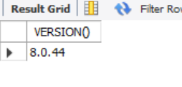
- Use the SELECT command to evaluate 4x4x4 and name the column Cube of 4.
SELECT 4*4*4 AS "Cube of 4";
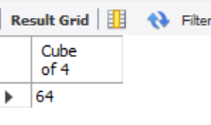
- Display your name with SELECT.
SELECT "Lyndy Belarmino" AS "Name";
